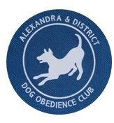Paws

Express

Newsletter of Alexandra & District

Dog Obedience Club Inc April 2025

Patrons: Betty Tulloch, Doug Norman B.Sc.(Hons), B.Vet.Sc.(Hons)

**FROM THE PRESIDENT**

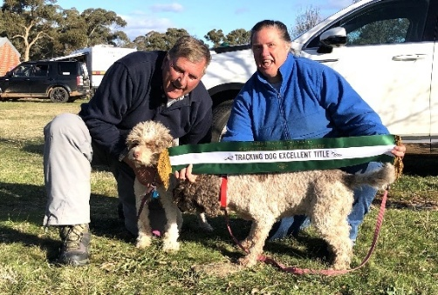Welcome to 2025 everyone, it’s been a hot one, hopefully we will see some cooler weather in the next few weeks. We have our second group of puppies starting and have had our first members’ competition. For the newbies we hold several members’ competitions throughout the year, and the dogs scores get added up and at the end of the year there is an award for the top scoring pups. If you’re not quite up to the level that is required, you’re more than welcome to stay, watch and ask questions. The committee and instructors are in the process of organising several workshops to be run during the year – so keep your eyes open for updates!

I congratulate you all on being dedicated to training with your dogs, you will see progress with consistent practice and engagement with your dog. Some just want to train their dog with basic obedience, others enjoy the time spent with their best friend and want to go a little further with their training. Then there are the others that get hooked and start going that little bit further with different kinds of dog sports. The club has several members who compete in dog sports, if this is something you are interested in, ask your instructor who to talk to, most who do dog sport will be happy to talk ad nauseum about their favourite topic.

Keep up the good work, thank you for respecting your pups and their needs. Thank you to the volunteers who keep the club ticking over.

Happy Training

Fiona Mackey

**Join the Alexandra & District Obedience Club on Facebook**

#### Committee Members 2025

Fiona Mackey (President)

Debbie Callaway (Vice Pres.)

Geoff Hyland (Sec/Treasurer)

Sandice McAulay (Sec)

Jeanne Roberts

Joh Slattery

Jenny Hyland

Georgina Covington

Shane “Frog” Frean

Janene Millar

#### Life Members

Betty Tulloch

Greg Tulloch (Dec)

Lynne Walter

Maggie Hamill

Julee Hosking (Dec)

Bronwyn McFadyen

Jeanne Roberts

Barb Tanner

#### Honorary Members

Doug Norman B.Sc(Hons) B.Vet.Sc(Hons)

Mike Hosking

Chris Chester

David Roberts

#### Instructors

Jeanne Roberts

Ann Jelinek

Pam Poole

Jenny Hyland

Debbie Callaway

Consuela Middleditch

Georgina Covington

***Newsletter:*** *Cath Keogh*

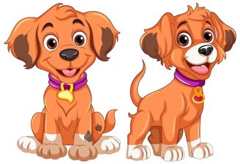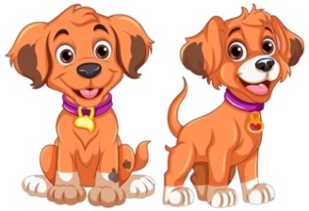

**TRAINING TIPS**

LET THE GAMES BEGIN!

*“Great dog trainers have broad skills not inflexible ideologies”.*

*~Ralph Weber~*

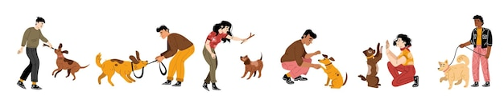

A big welcome to our 2025 training year to all our members, whether you are returning for another year or embarking on your first, it’s lovely to see you all, and your canine companions.

How we teach our dogs is just as important as what we teach them.

From the moment you bring our new puppy/dog home, you imagine walks in the park; play dates with a friendly dog; going to the beach; visiting family and friends.Laughing and sharing a happy life together.

Six months on and reality sets in. Your new puppy/dog won't come when called; jumps up on visitors; pulls on the lead and ignores you and you don't have time to take it for a walk EVERY SINGLE DAY! You become stressed, worried and overwhelmed by it all. Does this sound familiar? I'm sure many of you can relate to this. I know I can!! What to do??

Here at ADDOC we believe that using Positive Reinforcement as your training method can help turn this around and that if you combine this with PLAYING GAMES and having FUN you have a winning formula.

Why play games and have fun?

**Games build a strong bond with our dogs**

* We all have an inbuilt desire to play with our dogs. Tossing a stick, a ball or a frisbee are old favourites. Something humans have been doing with their dogs for centuries! This is quality time spent with our dogs where they want to be with us and co-operate with and interact with us in a positive way.

**Games are simple and easy to teach**

* Most dogs love to chase (fetch) something; most dogs love to play tug. You can use these simple games as a learning tool.
* The fetch game can build a strong recall and also help with impulse control - how to wait until told to "Fetch It".
* Tug is a fun game in itself, which can also teach your dog impulse control - how to be gentle when it comes to using their mouth.
* Neither of these games are difficult to understand or teach.

**Games are a pathway to success.**

* You're training your dog, even if you don't realise it. There are several recall games which dogs love to play. I have used a couple of them with my young dog and think the results are amazing. They are "Get It!" and "Tornado!" (See end of article for how to play details).
* You can reinforce good behaviours and have fun all at the same time.
* Nothing in dog training happens overnight but with games you will be having lots of fun with your dog along the way, and more importantly you will achieve the result you are hoping for.

**Games provide motivation for you and your dog.**

* You are motivated because it is relatively easy to play a game and you will enjoy yourself.
* You will have the satisfaction of doing something positive and proactive with your dog.
* Your dog will be motivated because it loves to be doing something with you and it it FUN!

**Games provide physical exercise.**

* You may have heard the saying: "A good dog is a tired dog"? Dogs need physical exercise each day, and if those needs aren't met they can get into trouble by developing destructive habits (such as chewing - usually something very special to you - or digging) to pass the time.
* If your timetable limits how much time you can spend walking your dog, then games like tug, fetch and frisbee are physically tiring for dogs and a couple of quick sessions a day can provide your dog with plenty of exercise.

## Games provide mental stimulation.

* Often overlooked, mental exercise is just as important as physical exercise.
* Mentally stimulating activities or "Brain Games" are a fun way to enrich your dog's life.
* Dogs love nose work games and you will have fun watching and learning how amazing their sense of smell is and how they use their noses. Two that I have uses are "Hide & Seek!" and "Treasure Hunt".

## Games relieve boredom

* A bored dog - one with nothing interesting to occupy itself - will look for ways to create its own entertainment, which often involves undesirable behaviours such as excessive barking and running the fence or chewing up your shoes.
* If you have played games that physically and mentally exhaust your dog then it will be content to relax and wait for your next session together.

**Games relieve stress.**

* Yes, it's true! Games can relieve stress for both you and your dog.
* When you arrive home tired and maybe fed up after a tough day at work, your dog will be delighted to see you and full of enthusiasm. Even if you feel that the last thing you want to deal with is a dog who is delighted tosee you: Stop! Choose a game and spend 15mins relaxing and laughing with your dog. It's the best pick me up I know of!!!!

To sum up: **PLAY IS POWERFUL! FUN IS FABULOUS! SUCCESS IS SWEET!**

***Ref: So Much PETential; Kathy Kawelec: Cognitive Dog Training:"Puppy Leaks'***

***Be the most interesting human your dog has ever met.***

***~Ralph Weber~***

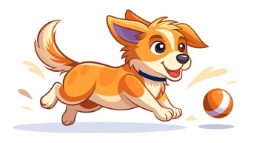



**Fun games to play with your dog.**

**RECALL GAMES**

1. **Get It!**
   * Show your dog a tempting treat.
   * Toss it a short distance away- you can use the cue "Get It!".
   * When your dog comes back looking for another treat, repeat the above.

•Don't treat when your dog comes back - you want it to learn that the faster it returns to you the quicker it gets to chase after another treat!

1. **Tornado\*** (Similar to "Get It!" but faster).
   * Throw one piece of food away from you, as your dog runs back towards you and gets close to you, lure them around your body, 360 degrees with a piece of food, and throw another piece of food away again.
   * Try going in each direction around your body.
   * *Note:* Once my dog knew how to play this game, I introduced the cue "Come!" in a happy voice+ the cue "Around" with a hand signal to send him around my body either to the left or the right.

**IMPULSE CONTROL GAMES**

1. **Mouse Game:** Loose or off lead, no verbal cues.
   * Have your dog sitting.
   * Place a few pieces of food on the floor or in a bowl nearby.
   * If the dog moves towards the food, cover it with your hand.
   * Wait for the dog to back off and maybe sit.
   * Remove your hand and say "Yes" and/or use a clicker, releasing the dog to the food OR give treat, say "Yes" enthusiastically and/or use a clicker.
   * Mix these 2 reward actions up, be unpredictable.
2. **Tug Switch.**
   * Initially use 2 similar tugs.
   * Play with tug 1, stop moving that tug and start moving tug 2. The dog should drop tug 1 and start playing with tug 2.
   * You can play this activity on the move, so the dog is leaping from one tug to another.
   * Introduce cue "Switch" to change tugs.
   * Introduce different tugs.
   * You can throw tug 1 out (or a frisbee) when the dog retrieves and returns, throw tug 2 or frisbee 2 out. Have fun!

**NOSE WORK GAMES.**

1. **Hide and Seek.**

You can play this game inside or out and use either a favourite toy or hide yourself.

Using a favourite toy, get your dog to “sit” and “wait” (you might need a helper at first).

Go a short distance away and hide the toy in an easy to find spot.

Return to your dog and say, “Where is it?” “Find it”.

Make a big fuss and give lots of praise when your dog returns with the toy, repeat.

Over time gradually make the toy more difficult to find. (Have a special toy you only bring out for this game).

Hiding yourself: use the same principal. Inside, hide in another room, behind a door, in a cupboard, etc. Outside, wait until your dog is distracted and then hide around a corner of the house, behind a tree etc. Make the game more difficult over time.

Be creative with these games you are only limited by your imagination!

1. **Treasure Hunt.**

Scatter a small bowl of treats all over your lawn and then watch your dog have fun finding all the bits.

If you really want to tire your dog out, do this with their breakfast or dinner, and scatter their dry dog food all over the lawn for them to find. This provides a lot of mental and physical exercise at the same time.

I hope you and your dog have fun learning these games.

Happy game time.

Laughter is the best medicine for you and your dog.

Jeanne

*“The greatest pleasure pf a dog is that you may make a fool of yourself with him, and not only will he not scold you but he will make a fool of himself too”.*

*~Samuel Butle~*

* ***Adapted from and with acknowledgement to ''Absolute Dogs'***

**Club Calendar**

|  |  |  |
| --- | --- | --- |
| **APR** | 5 | Intake Day 2 2025 |
|  | 6 | Club Training wk1. Members Comp |
|  | 13 | Club Training wk2 |
|  | 18-21 | Easter  - ***No Training*** |
|  | 27 | Anzac Day Public holiday – ***No Training*** |
| **MAY** | 4 | Club Training wk3 |
|  | 11 | Club Training wk4 |
|  | 18 | Club Training wk5 |
|  | 25 | Club Training wk6  Workshop - Georgina |
| **JUNE** | 1 | Club Training wk7 – Rally/CCD/Agility |

# 

# NEW MEMBERS

|  |  |
| --- | --- |
| 2 February |  |
| Ami/Darren Taylor & *Coco* | Julia/Dylan White & *Daisy* |
| Nung Fegan & *Maxi* | Pam Poole & *Striker* |
| Caitlyn Musgrove & *Waffle* | Sam Fawke/Jamie Lynch & *Rusty* |
| Jeremy Elliott/Donnie Kamarudin & *Euky* | Sally Gilbert & *Kelley* |
| Cathy Bouchet & *Lou* | Nadeane/Andrew Peacy & *Dozer* |
| Megan Boerlage & *Archie* | Karen Howden & *Gidget* |
| Helen Watson & *Barney* | Caitlin Pottage & *Nellie* |
| Jayme-Lee Saxby & *Rosie* | Jude Hill & *Ollie* |
|  |  |
| 6 April |  |
| Chris/Mike Wasley & *Pippa* | Sarah Menzies & *Ollie* |
| Annie/Jamie Baird & *Jady* | Charlie Poulton & *Ted* |
| Sue McNair, James Riley & *Bunji* | Jacqui/Ian Pearson & *Freja* |

